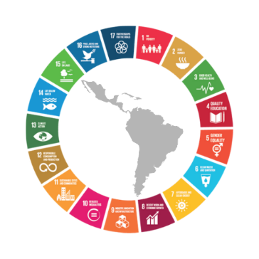
Civil society calls for dialogue with the governments of
Latin America and the Caribbean

Action for the # ForoALC2030

The Civil Society of the Forum of the Countries of Latin America and the Caribbean on Sustainable Development, organized in the Linking Group, launches a Campaign in the media and social networks to raise the urgent need to strengthen the dialogue between governments and civil society, in the framework for the implementation of the 2030 Agenda, to overcome the short and long-term impacts that the Covid19 pandemic will leave us.

The Economic Commission for Latin America and the Caribbean (ECLAC), in agreement with the Cuban government, had proposed to hold the Fourth Meeting of the Forum of the countries of Latin America and the Caribbean in virtual format on March 31, before the suspension of the same in-person, which was to be held from March 28 to 31, 2020. But also the virtual modality was suspended; therefore, the possibility of holding the Fourth Meeting has an uncertain future. We ask that its implementation be postponed.

Faced with this situation, the Linking Group, made up of 20 groups that bring together more than 400 organizations and networks in the region, has decided to carry out this awareness and mobilization campaign. We believe that this crisis that we are going through generates new challenges and demands a new pact of social justice for all people.

Today more than ever, the 2030 Agenda and the 17 Sustainable Development Goals, with its motto of #Leavingnoonebehind constitute a challenge and an inescapable moral and ethical imperative. That is why we demand that governments postpone the planned meeting and that in the meantime actions be taken to promote dialogue between governments and civil society. COVID19 changes our lives and particularly affects those who have less and are the ones that most need our action. We need to adapt responses to the crisis generated by the pandemic and as a civil society we want to participate.

Please find enclosed the materials of the Campaign that begins on March 31, 2020 and will continue in the coming weeks with other messages.

* Civil Society Linking Group of the Forum of the countries of Latin America and the Caribbean on Sustainable Development

For more information contact 👇

Rosario Galarza, Human Rights Officer - RIADIS (focal point)
rosario.galarza@riadis.org

#NoLeaveAnyoneBehind
Messages :

The virtual #ECLACForum2030 was postponed due to #COVID19. We insist: only an inclusive, frank and transparent dialogue between governments and civil society will allow us to find solutions to overcome the COVID19 crisis and fulfill the #Agenda2030 @ECLAC

The creation of the Civil Society Participation Mechanism in the 3rd Regional Forum on Sustainable Development was an important step, but it’s not enough to ensure effective government-CSO dialogue. #ECLACForum2030 @ECLAC

Five years after the approval of #Agenda2030, #LAC is still far from meeting its objectives. We suffer from stagnation of economic growth and so many other problems that will make it more difficult to confront #Covid19. #ECLACForum2030 @ECLAC

